ASSIGNMENT:10.2

**CHADA SATHWIKA REDDY**

**2403A51334**

**BATCH:14**

**TASK1:**

**PROMPT:**

Here is a Python program meant to calculate the factorial of a number and check if it's bigger than 10. Please review and correct any basic coding errors, remove unused variables, improve readability, and follow Python best practices. Then provide the corrected version with inline comments.

**CODE and OUTPUT:**

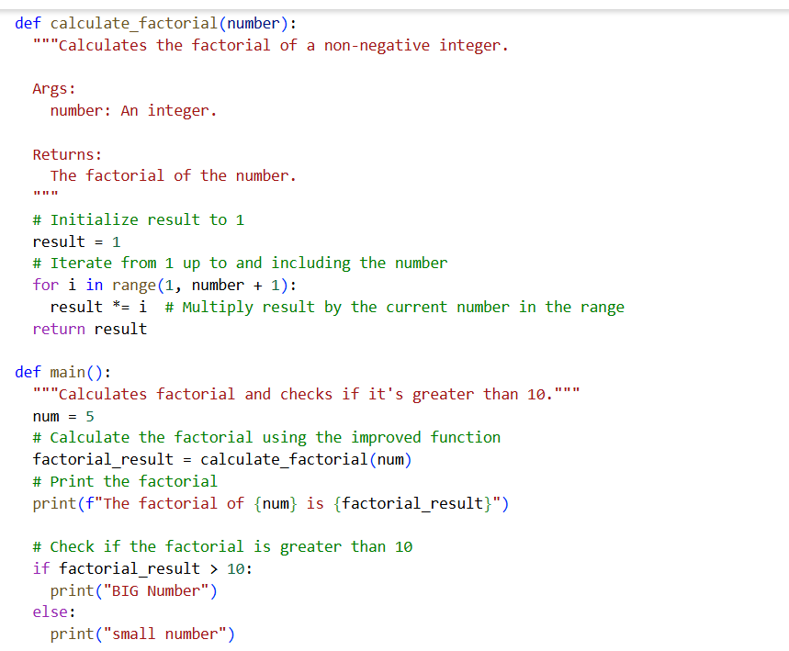

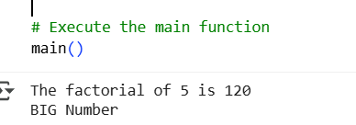

**OBSERVATION:**

**Issues Identified**

1. Incorrect range in factorial loop:
   * The range range(1, n) only goes up to n-1, so it misses multiplying by n.
   * Fix: Use range(1, n+1).
2. Unused variable x:
   * Variable x is defined but not used anywhere.
   * Fix: Remove x.
3. Unused variable t:
   * Variable t=10 is set but never used.
   * Fix: Remove t.
4. Style improvements:
   * Variable names like FACT should follow snake_case in Python (fact).
   * The print() function can use f-strings for cleaner output.

**TASK2:**

**PROMPT:**

Write the Python Fibonacci code as shown.

Ask an AI to:

* Improve variable names
* Add inline comments
* Apply PEP8 formatting

Evaluate improvements in readability.

**CODE AND OUTPUT:**

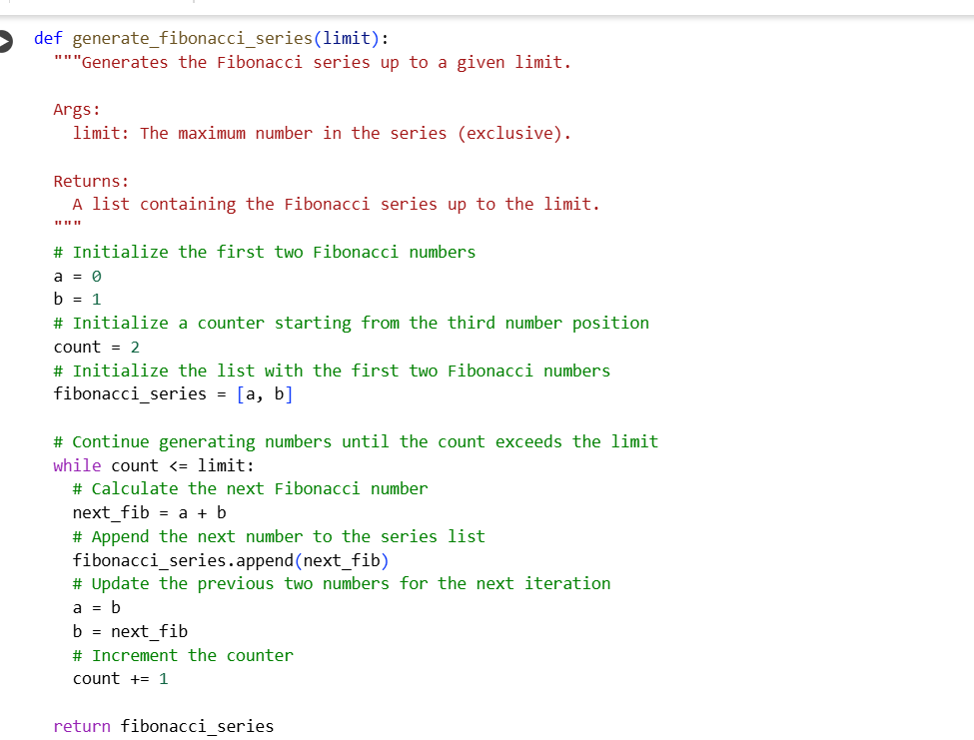

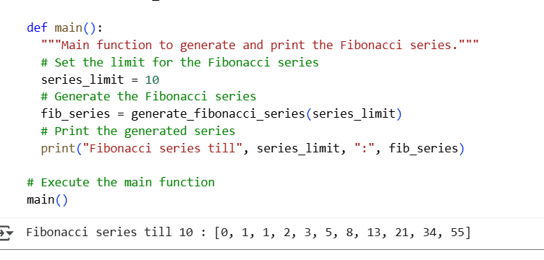

**OBSERVATION:**

Unclear variable names (f1, xX, Zz, c, d, etc.).

No comments explaining logic.

Violates PEP8:

* Inconsistent casing (NN, xX)
* Poor function naming (f1, m)
* Spacing and readability could be improved.

**TASK 3:**

**PROMPT:**

Generate a module-level docstring and individual function docstrings in NumPy style for a basic calculator Python script that has four functions: add, subtract, multiply, and divide.

**CODE AND OUTPUT:**

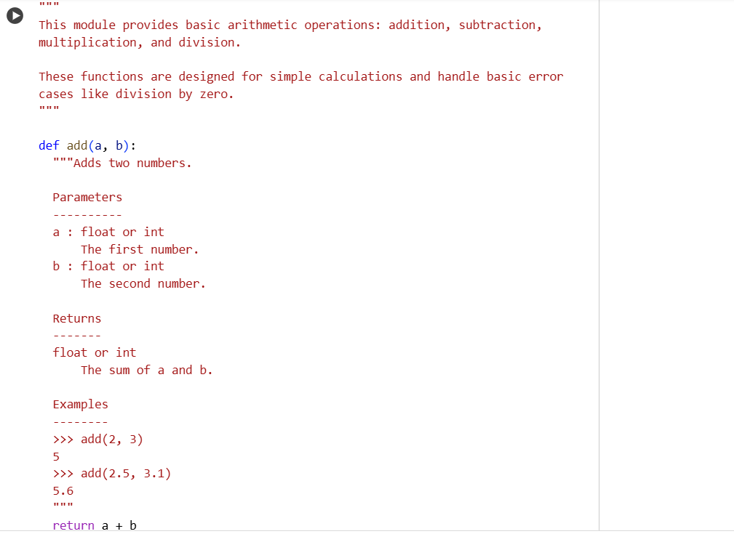

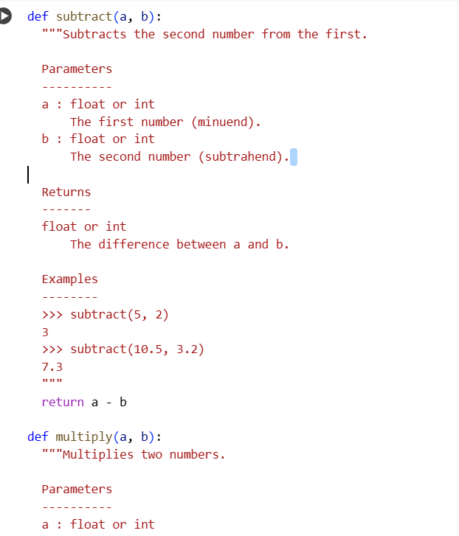

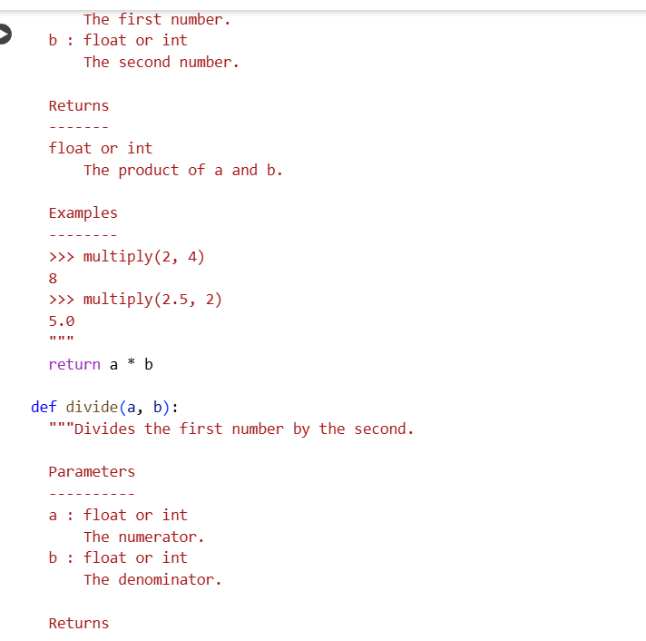

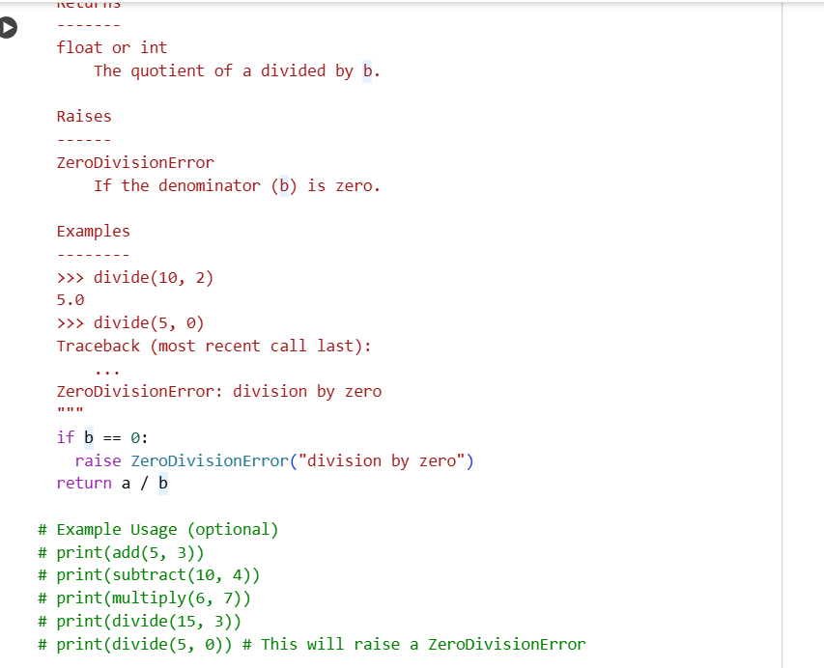

COMPARISION:

| **Element** | **Manual Docstring** | **AI-Generated Docstring (Prompt Output)** |
| --- | --- | --- |
| **Module Docstring** | Describes the module and lists all 4 functions. | Nearly identical, lists purpose and functions clearly. |
| **add(x, y)** | "Add two numbers and return the result." | Same structure, uses NumPy style. |
| **subtract(x, y)** | "Subtract the second number from the first and return the result." | Clear and matching. |
| **multiply(x, y)** | "Multiply two numbers and return the result." | Same wording. |
| **divide(x, y)** | Added a Raises section to handle divide-by-zero edge case. | AI also includes Raises section if prompted well. |